**Plugging into the future an exploration of Electricity Consumption patterns**

**Introduction**

India is the world's third-largest producer and third-largest consumer of electricity. The national electric grid in India has an installed capacity of 370.106 GW as of 31 March 2020. Renewable power plants, which also include large hydroelectric plants, constitute 35.86% of India's total installed capacity. During the fiscal year (FY) 2019–20, the total electricity generation in the country was 1,598 TWh, of which 1,383.5 TWh generated by utilities. The gross electricity consumption per capita in FY2019 was 1,208 kWh.

In 2015-16, electric energy consumption in agriculture was recorded as being the highest (17.89%) worldwide. The per capita electricity consumption is low compared to most other countries despite India having a low electricity tariff

In light of the recent COVID-19 situation, when everyone has been under lockdown for the months of March to June the impacts of the lockdown on economic activities have been faced by every sector in a positive or a negative way

**Purpose** :

People use electricity for lighting, heating, cooling, and refrigeration and for operating appliances, computers, electronics, machinery, and public transportation systems.

**Empathy map**

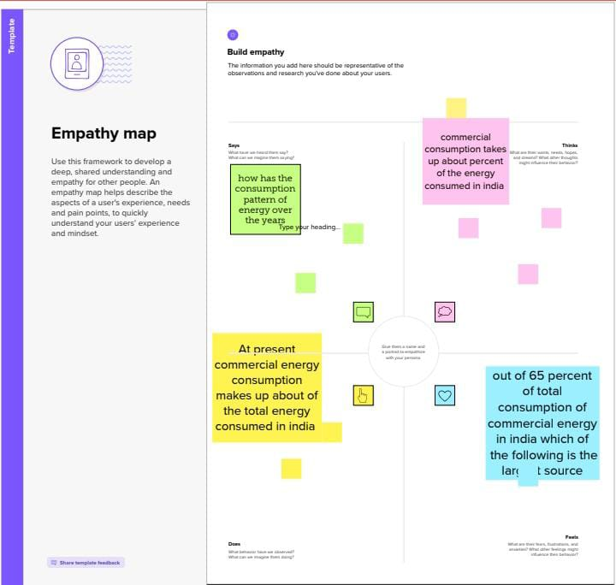

Brain storming map

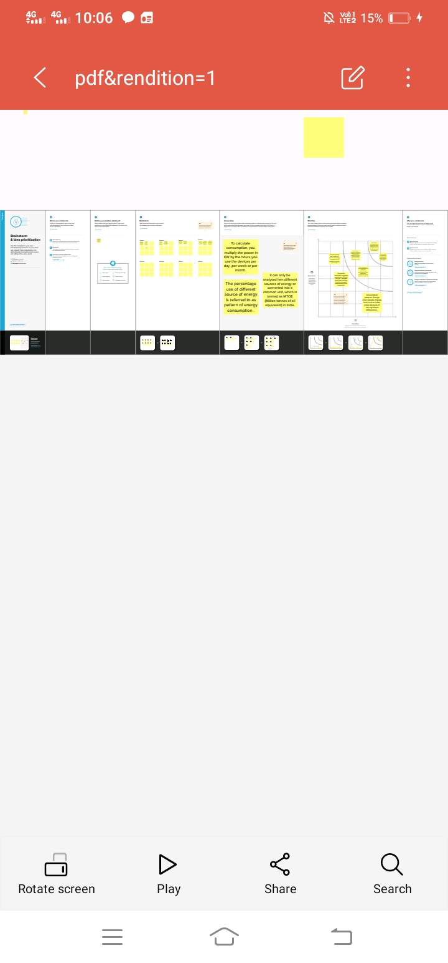

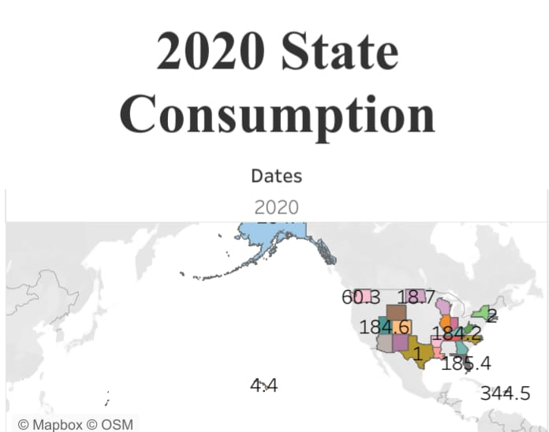

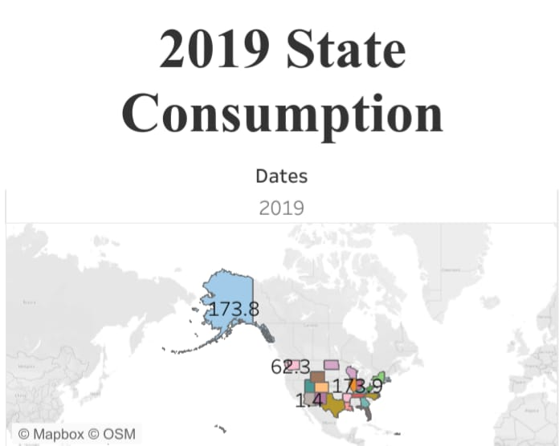

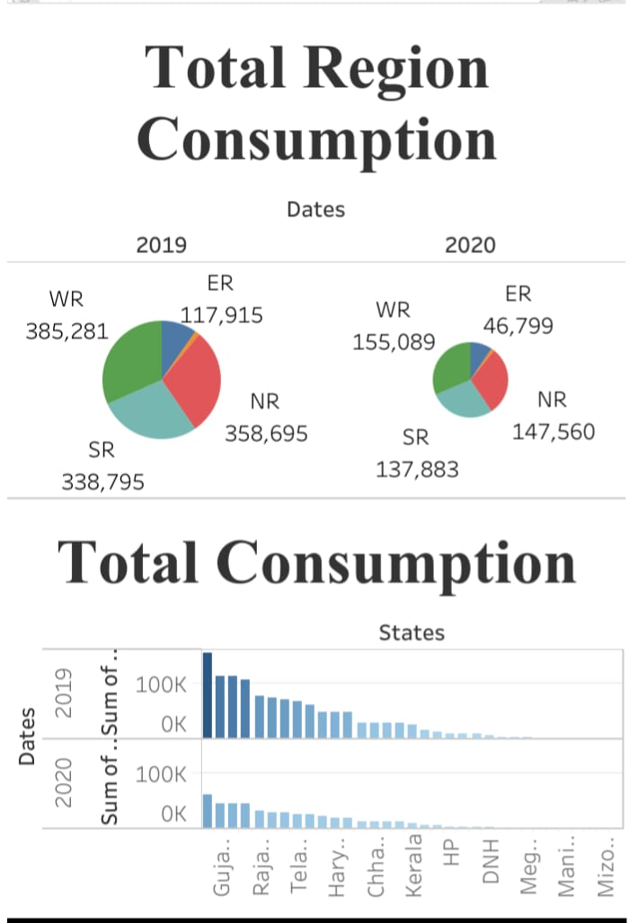

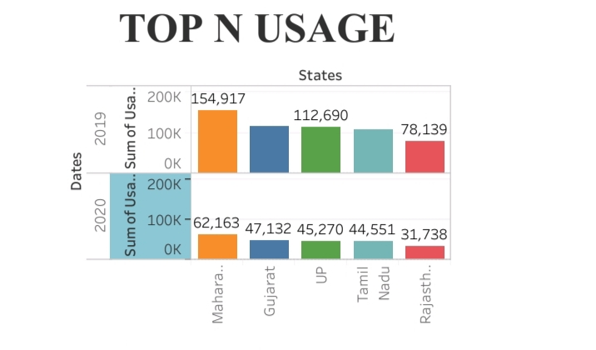

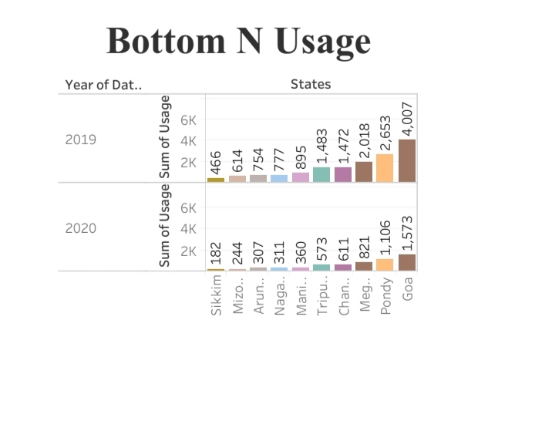

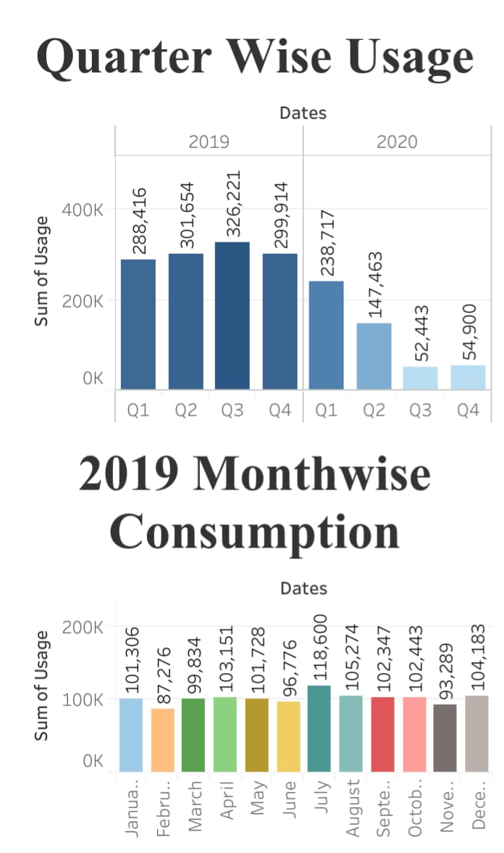

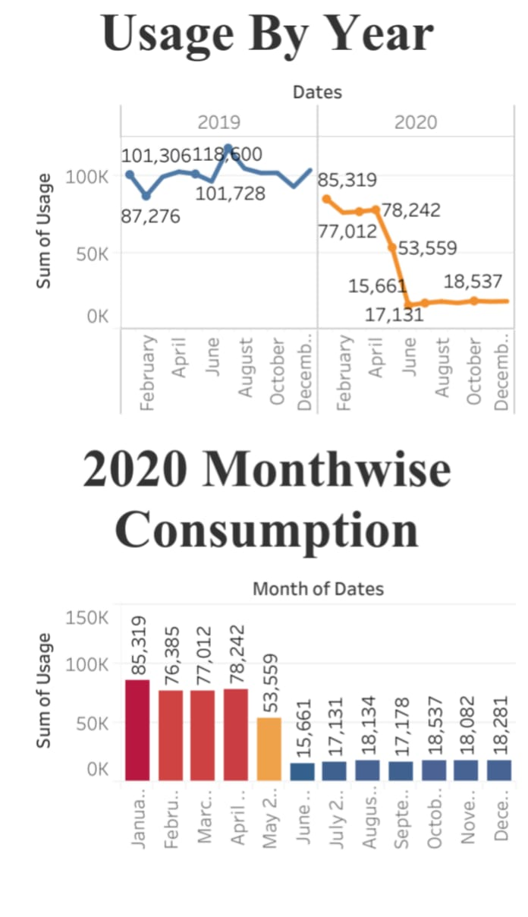

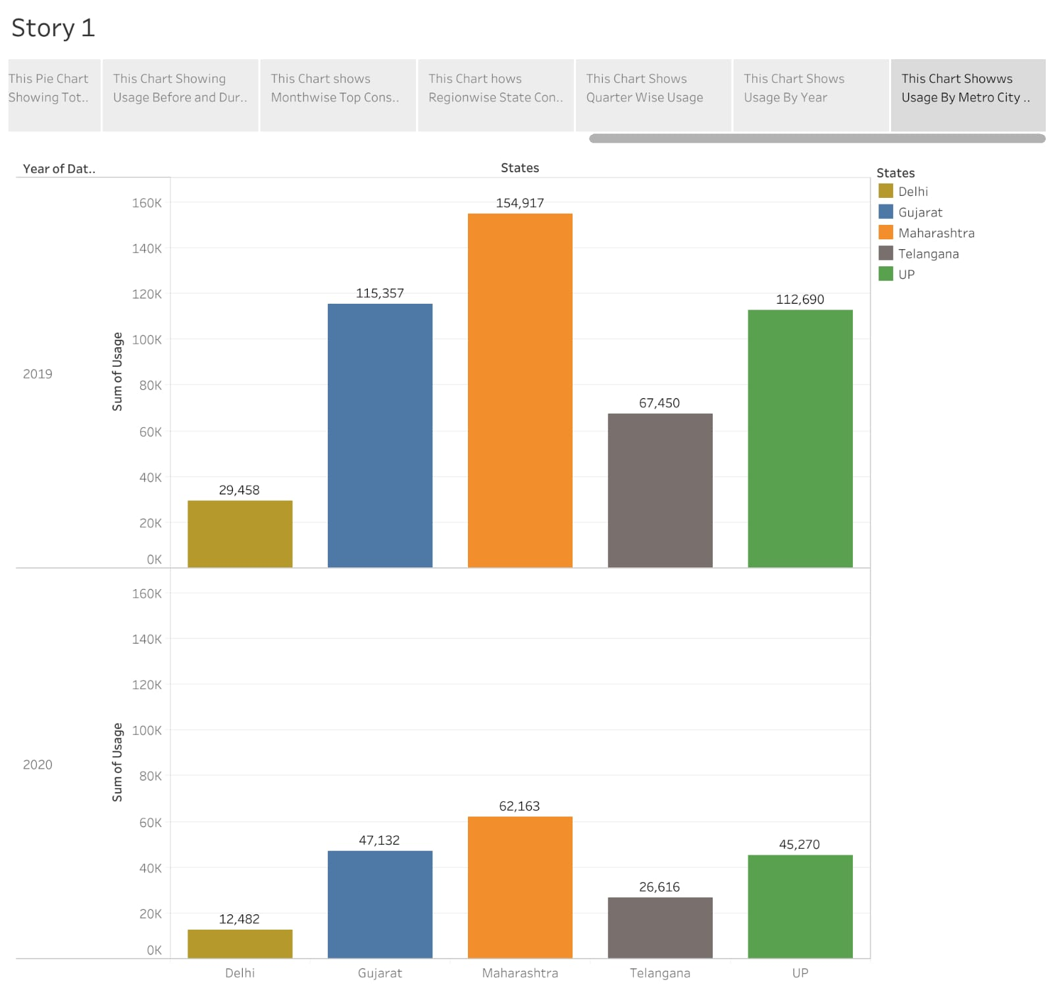

**Advantages :**

**1.low maintenance cost**

**2.no tail pipe emission**

**3.more efficient**

**4.it can be set up in many sizes**

**Disadvantages :**

**1.more expensive than gasoline**

**2.loss of fish species**

**3.dependent on precepitation**

**Conclusion :**

**Electricity is the backbone of modern society .our life will go back to the primitive age without electricity.there is a need for national use of Electricity, as it is largely produced from non - renewable sources like coal and water .**